Utah's Promontory Point Marks the Spot Where the United States were United

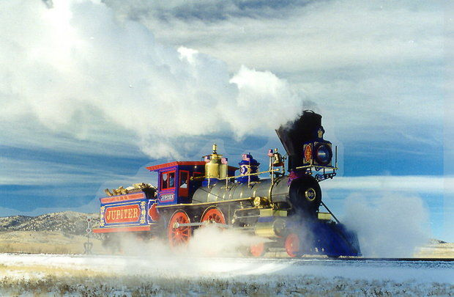
The Jupiter steams across the Utah plains during a winter weekend run at the Golden Spike National Historic Site. Although both of the original locomotives that met when the transcontinental railroad was completed were destroyed, the engines have been accurately reproduced and are in frequent use. (Golden Spike National Historic Site)

It was marked by a simple concrete pylon holding a brass plaque. It had become weathered and cracked and its importance diminished over the decades, almost forgotten by all but those few with an appreciation of its importance.
But the monument, on the windswept hill known as Promontory Point, marked the moment the United States became the United States.
It was here, on the high desert above The Great Salt Lake, that east met west in a simple ceremony that tied the nation together with completion of the Transcontinental Railway.
The Central Pacific's Jupiter and the Union Pacific's locomotive 119 faced one another, just a few feet apart, as the first ceremonial spike was tapped into the final rail linking the two lines. A telegraph operator keyed in the word D-O-N-E to a nation awaiting the news. In 1869 it was the equal of today's baby boomers waiting for the first images of the man on the moon 100 years later.
The companies were in a race. For good reason. The project was subsidized by the federal government to the tune of between $16,000 to $48,000, plus 10 land sections (160 acres) for each mile of track laid.
As the race to completion neared, the Union Pacific laid 8.5 miles of track in a single day, and the president of the company bet $10,000 that the record couldn't be beat. So the Central Pacific crew leader assembled a team of his best men, who put down 10 miles and 56 feet of track in a single 12-hour shift. All by hand. It was called "the grand anvil chorus"
"The assembly line reached its grand climax during track laying. Eight men pulled rail from the iron truck and dropped it onto the ties. Spikers and screwers fastened the iron into place – 3 blows to each spike, 10 spikes to the rail, 400 rails, 4,000 spikes, and 12,000 blows to the mile" -- is how it was described.
To build the line, the Union Pacific tapped a pool of European immigrants and Civil War veterans, while the Central Pacific hired crews of Chinese laborers to claw their way through rock to create tunnels through mountains. The mortality rate for both companies was high. If dangers, disease or Indian attacks didn't kill you, there was always a chance that a knife fight in the rolling town called "Hell on Wheels" that followed the crew would.
Actual construction took just four years to build the lines over rivers, across plains, through mountains. When completed, it allowed coast-to-coast travel in six days rather than six months.
But once the rail lines were linked, it didn't take long for Promontory Point to fade from prominence.
Six months after the Union Pacific and Central Pacific were joined, the Promontory site became just a whistle stop along the way. In 1903 engine 119 was sold for scrap. The Jupiter met the same fate three years later. By the 1930s, rail service to the site was cut off, in favor of a shorter route that replaced it. Then in 1942 there was a ceremonial "undriving" of the final spike and 90 miles of the rail line was ripped out to feed America's war effort in Japan and Europe.
All that remained was the gravel right of way and the concrete pylon, high on the windy hill.
What was left wasn't enough for Bernice Gibbs Anderson, a local historian who wrote to President Harry Truman that the Golden Spike site needed to be preserved and protected.
"This is sacred soil, dedicated to the sacrifices of the thousands who labored in the great race to build the first transcontinental railway," she wrote in 1957. "Will it take its rightful place in the heritage and traditions of America, preserved and protected by a grateful government, or will it remain desolate and forgotten to sink into oblivion?"
She was relentless in her efforts and in 1957 the spot was designated a National Historic Site.
Today it is under the care of the National Park Service, which has established a comprehensive visitor center to honor its place in history.
Centerpiece of the site are a pair of working locomotives that are exact replicas of the Jupiter and the 119.
"There were no plans for the engines," explained David Kilton, the ranger who oversees the site. "The company used all the photos from the dedication and all the drawings from engines built at the time to come up with engines they say are within a half-inch of the originals."
During the summer, the locomotives are steamed up and pulled onto the rails to go nose-to-nose and duplicate the meeting of the two lines. On special occasions, a full re-enactment takes place, with volunteers and train enthusiasts in period costumes.
And at the entrance to the center sits the original concrete pylon with a brass plaque, for years the only record of how America changed on that windy hill.

-- Jerry F. Boone

